**GUI on Marketing Campaign**

## **Introduction:** A response model can provide a significant boost to the efficiency of a marketing campaign by increasing responses or reducing expenses. The objective is to predict who will respond to an offer for a product or service.

**GUI**

## **Methodology**: In order to predict the marketing campaign response we trained the given data using a support vector machine classifier algorithm from the sci-kit-learn library.

## **Dependencies**: Scikit-learn, Stremlit, Python

## **Pipeline:**

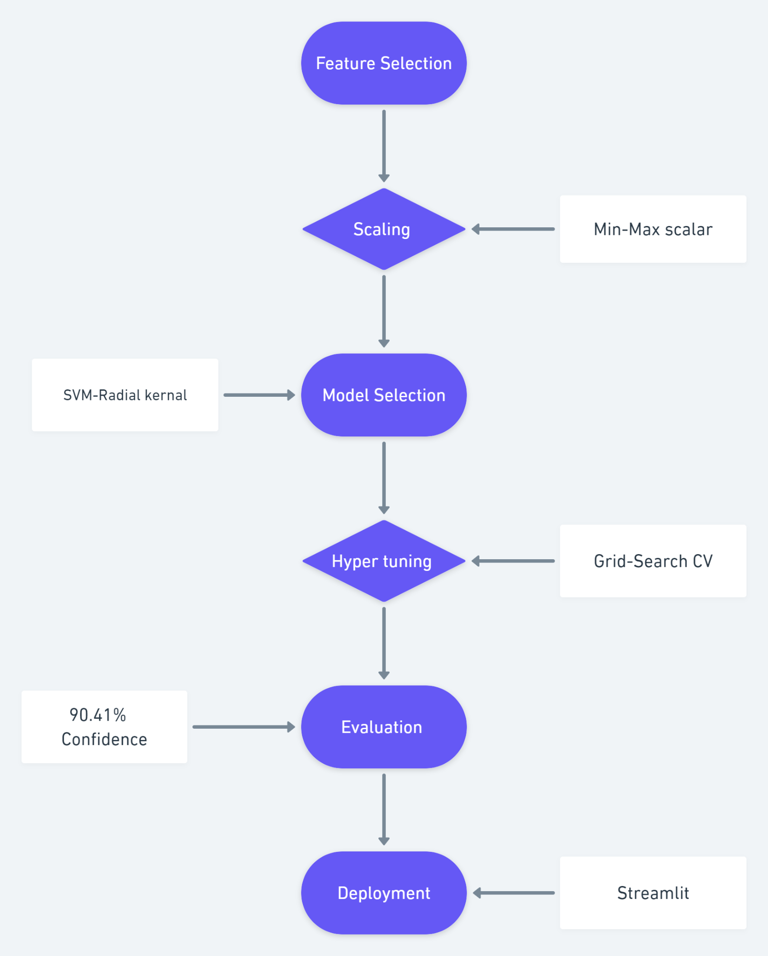

**Results**: The model achieved 90.4% confidence in predicting the response. we created an interactive user interface using streamlit which enable us to perform prediction in real-time.

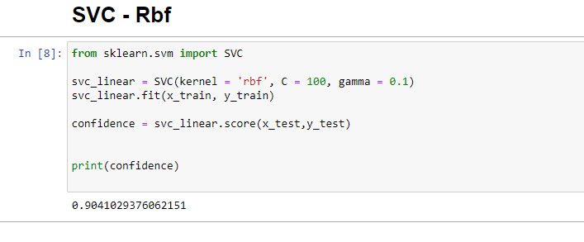

**GUI**

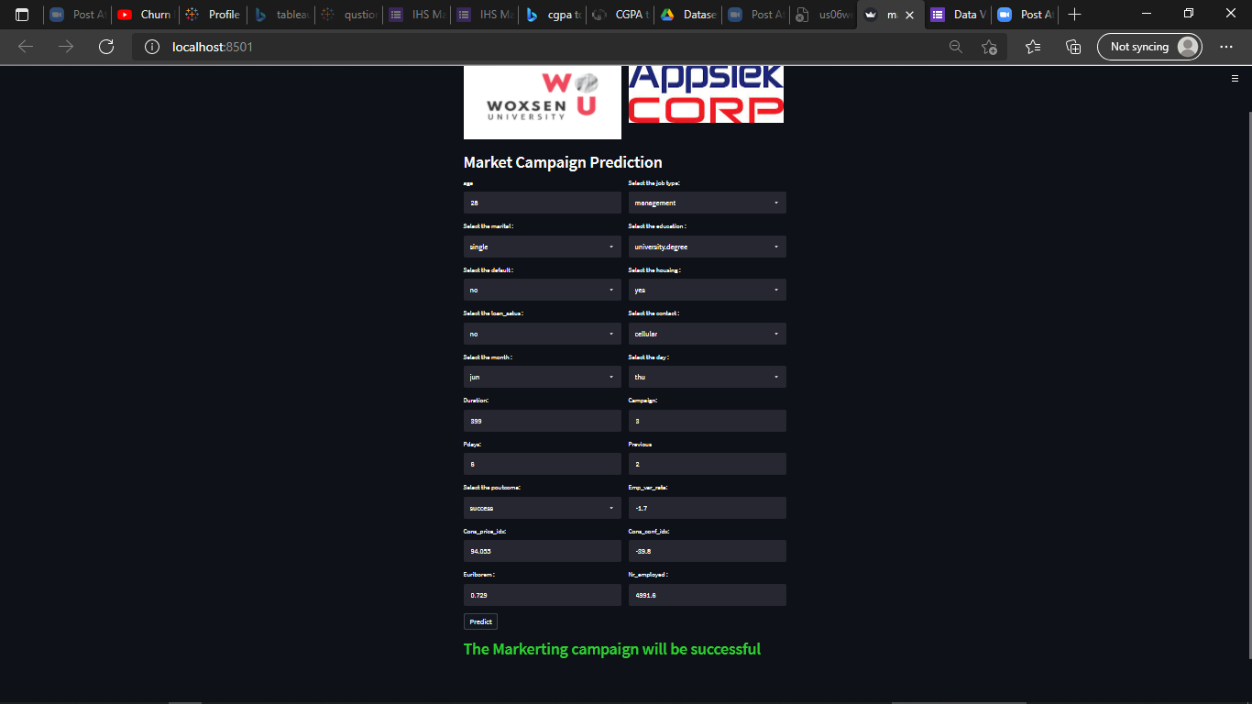

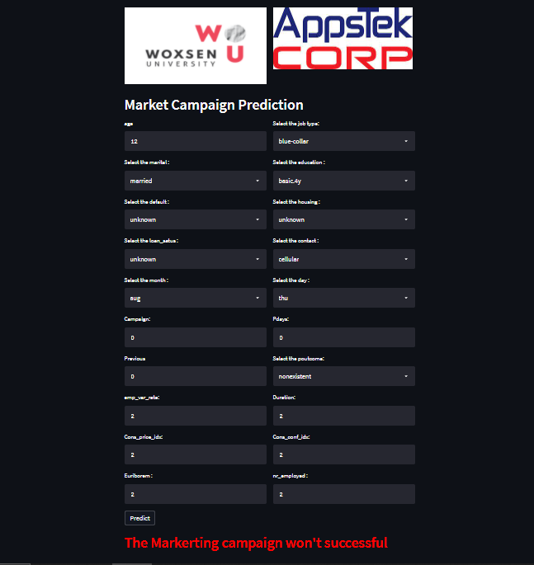

**Conclusion:** we created an interactive user interface using streamlit which enable us to perform prediction in real-time with 90.4% Confidence.